***Question one***: find the global minimum of $f(x)=\sqrt{x}$ in the interval [0, 10]

**IMAT 5232**

*Computational Intelligence Optimisation*

**Interim Assessment One**

*Authored by*

**Adam Leonard Hubble**

*P17175774*

*P17175774@my365.dmu.ac.uk*

First-order derivative $f'(x)$:

* $\sqrt{x}=\sqrt[2]{x^{1}}$ or $x^{\frac{1}{2}}$
* $x^{\frac{1}{2}}= \frac{1}{2}x^{\frac{1}{2} - 1}=$ $\frac{1}{2}x^{-\frac{1}{2}}$ (power rule)

$\frac{1}{2}x^{-\frac{1}{2}}= \frac{1}{{2x}^{\frac{1}{2}}}= \frac{1}{2\sqrt{x}}=\frac{df(x)}{dx}$

$\frac{df\left(x\right)}{dx}=\frac{1}{2\sqrt{x}}⇒x$ is never equal to 0 when $0<x<10$ (no stationary point(s) – constantly increasing)

$\frac{1}{2\sqrt{x}}$ is never zero given the implications of the denominators operation, meaning that there are no solutions for $f\left(x\right)=0$ (no null derivatives); where $\sqrt{x}$ has no stationary point(s) when $0<x<10$. Relating to the interval provided, it can be assumed that the lower bound of the search space 0 is potentially the objective-functions global minima (critical point where $x=0$), when aligned with the functions first-order derivative, for which presents a positive, continuous gradient or slope relation; the function can be said to be constantly increasing.

Second-order derivative $f''(x)$:

$\frac{1}{2\sqrt{x}}= \frac{1}{2}\left(\frac{1}{\sqrt{x}}\right)$

* $\frac{1}{2}\left(\frac{1}{\sqrt{x}}\right)= \frac{1}{2}\left(x^{-\frac{1}{2}}\right)$ (exponent rule)
* $\frac{1}{2}\left(x^{-\frac{1}{2}}\right)= \frac{1}{2}\left(-{\frac{1}{2}x}^{-\frac{1}{2} -1}\right)$ (power rule)

$\frac{1}{2}\left(-{\frac{1}{2}x}^{-\frac{1}{2} -1}\right)=-\frac{1}{4x^{\frac{3}{2}}}= \frac{d^{2}f(x)}{dx^{2}}$

Given that the first-order derivative of the objective-function does not satisfy a stationary point, calculating the second-order derivative for said function is not necessary but is rather purposed for demonstrating the procedure.

Search space bound check (critical point(s) endpoints of the domain), where $f\left(x\right)=\sqrt{x}$ and $x$ = 10: $\sqrt{10}=3.16227766$, which is inevitably greater than 0, for when $x=0$.

Therefore: global minimum = 0 when $x=0$ and global maximum $≈$ 3.1623 when $x=10$, for the given objective-function $f\left(x\right)=\sqrt{x}$ when $x$ is subjected to the interval [0, 10]; alternatively, as $f\left(x\right)=\sqrt{x}$ when $0<x<10$.

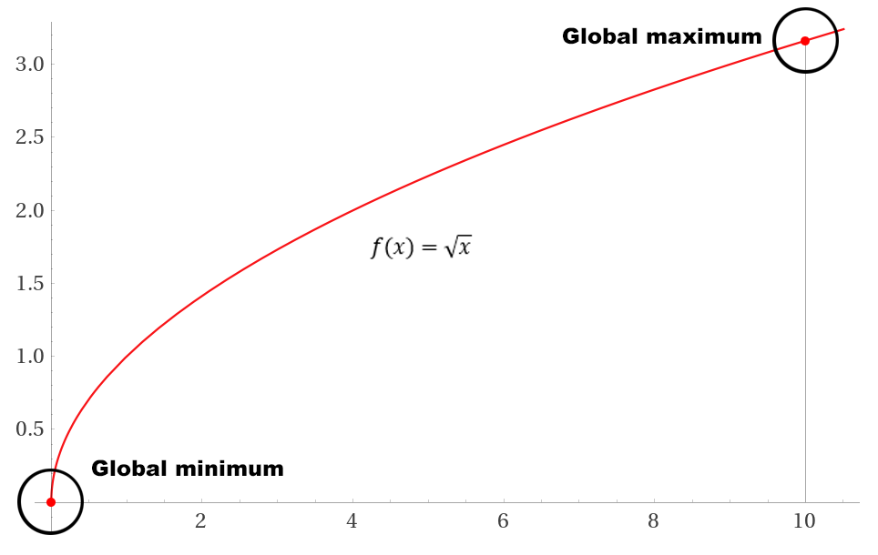

***Question two***: find the global minimum of $f(x)=log(x)$ in the interval [1, 10]

First-order derivative $f'(x)$:

* $log(x)=log_{e}(x)=ln\left(x\right)$ (natural logarithm)

$ln\left(x\right)=\frac{1}{x}= \frac{df(x)}{dx}$

$\frac{df\left(x\right)}{dx}=\frac{1}{x}⇒x$ is never equal to 0 when $1<x<10$ (no stationary point(s) – constantly increasing)

$\frac{1}{x}$ is never zero given the implications of the divisive operation, meaning that there are no solutions for $f\left(x\right)=0$ (no null derivatives); where $log(x)$ has no stationary point(s) when $1<x<10$. Corresponding with the interval provided, it can be assumed that the lower bound of the search space 1 is potentially the objective-functions global minima (critical point where $x=1$), when aligned with the functions first-order derivative, for which presents a positive, continuous gradient or slope relation; the function can be said to be constantly increasing, parallel with the preceding example.

Second-order derivative $f''(x)$:

* $\frac{1}{x}= x^{-1}$ (exponent rule)
* $x^{-1}=-1∙x^{-1-1}$ (power rule)

$-1∙x^{-1-1}=-\frac{1}{x^{2}}= \frac{d^{2}f(x)}{dx^{2}}$

Alike the prior example, as the first-order derivative of the objective-function does not satisfy a stationary point, calculating the second-order derivative for said function is not necessary but is yet again purposed for demonstrating the procedure, if proving the extremum of a stationary point were possible.

Search space bound check (critical point(s) endpoints of the domain), where $f\left(x\right)=log(x)$ and $x$ = 10: $log\left(10\right)=2.302585093$, which is inevitably greater than 0, for when $x=1$.

Therefore: global minimum = 0 when $x=1$ and global maximum $≈$ 2.3026 when $x=10$, for the given objective-function $f\left(x\right)=log(x)$ when $x$ is subjected to the interval [1, 10]; alternatively, as $f\left(x\right)=log(x)$ when $1<x<10$.

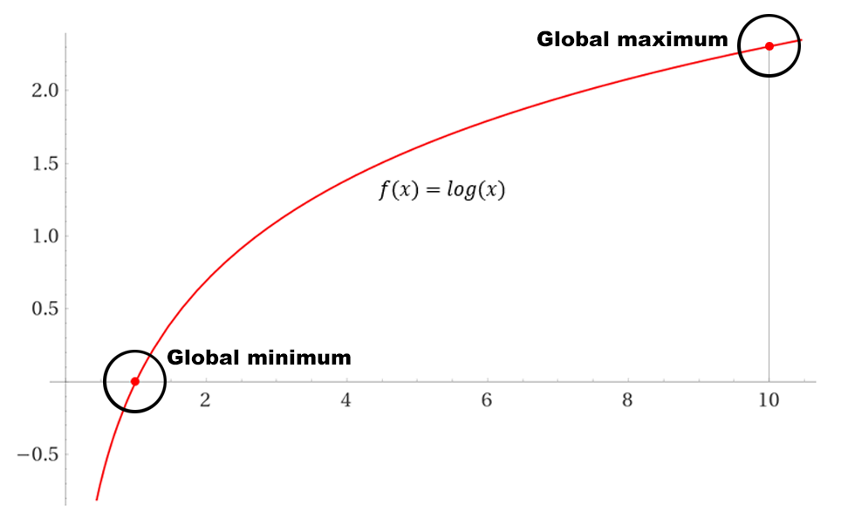

***Question three***: find the global minimum of $f(x)=x^{3}$ in $R$ in the interval [−1, 1]

First-order derivative $f'(x)$:

* $x^{3}=3x^{3-1}$ (power rule)

$3x^{3-1}= 3x^{2}= \frac{df(x)}{dx}$

$\frac{df\left(x\right)}{dx}=3x^{2}⇒x=$ 0 when $-1<x<1$ (one stationary point)

Second-order derivative $f''(x)$:

$3x^{2}=3(x^{2})$

* $3\left(x^{2}\right)=3∙2x^{2-1}$ (power rule)

$3∙2x^{2-1}=6x= \frac{d^{2}f(x)}{dx^{2}}$

$\frac{d^{2}f(x)}{dx^{2}}=6x⇒x=$ 0 when $-1<x<1$ (one stationary point)

Third-order derivative $f'''(x)$:

$6x=6= \frac{d^{3}f(x)}{dx^{3}}$

$\frac{d^{3}f(x)}{dx^{3}}=6⇒x≠$ 0 when $-1<x<1$ (stationary point is a point of inflection)

$6x$ is a flex point (point of inflection or transition in curve concavity), given that the derivative of the function when $x=0$ is neutrally 0, in focus of the interval [-1, 1], when $x>0$ the derivative of the function is positive and when $x<0$ the derivative of the function is negative. In realisation of said relation, when $x=0$, it is regarded as a stationary point but not an extremum as the function slope is continually increasing, from which there are no maximum or minimum extrema; this is proven by the third-order derivative: $6$, which evidently does not have a null derivative as $x≠$ 0 denotes.

Search space bound check (critical point(s) and endpoints of the domain), where $f\left(x\right)=x^{3}$, when $x=-1$: $-1^{3}=-1$, when $x=0$: $0^{3}=0$ and when $x=1$: $1^{3}=1$.

Therefore: point of inflection = 0 when $x=0$, global minimum = $-1$ when $x=-1$ and global maximum = 1 when $x=1$, for the given objective-function $f\left(x\right)=x^{3}$ when $x$ is subjected to the interval [-1, 1]; alternatively, as $f\left(x\right)=x^{3}$ when $-1<x<1$.

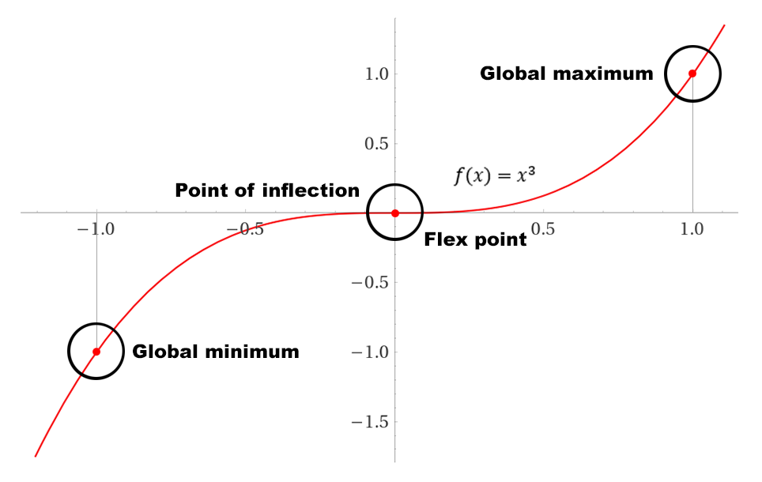

***Question four***: find the global minimum of $f\left(x,y\right)=4x^{3}+y^{3}-6xy in R^{2}$

Solve the gradient of the objective-function:

$∇f(x, y)=$ 0 $⇒\left\{\begin{aligned}\frac{∂f(x,y)}{∂x}=12x^{2}-6y=0 \\ \frac{∂f(x, y)}{∂y}=3y^{2}-6x=0\end{aligned}\right.$

Solve the system of equations:

$$\left\{\begin{aligned}12x^{2}-6y=0 \\ 3y^{2}-6x=0\end{aligned}\right.$$

* $3y^{2}-6x=0⇒y^{2}-2x=0$ (division by a multiple of three - simplify)

$y^{2}-2x=0⇒2x=y^{2}$

Thus: $2x=y^{2}⇒x=\frac{y^{2}}{2}$ or $\frac{1}{2}y^{2}$

* $12x^{2}-6y=0⇒12{(\frac{1}{2}y^{2})}^{2}-6y=0$ (substitute $\frac{1}{2}y^{2}$ into equation $12x^{2}-6y=0$)

$12{(\frac{1}{2}y^{2})}^{2}-6y=0$ $⇒$ $12 {∙ (\frac{1}{2})}^{2} ∙ {(y^{2})}^{2}-6y=0$

$12 ∙ \frac{1}{4} ∙ y^{4}-6y=0$ $⇒3y^{4}-6y=0$

* $3y^{4}-6y=0⇒{y(y}^{3}-2)$ (division by a multiple of three - simplify)

Hence: ${y(y}^{3}-2)⇒y=0$

* ${y(y}^{3}-2)⇒y=\sqrt[3]{2}$ or $2^{\frac{1}{3}}$

Therefore: ${y(y}^{3}-2)⇒y=0 ∨ {y(y}^{3}-2)⇒y=2^{\frac{1}{3}}$

$x=\frac{1}{2}y^{2}⇒x=\frac{1}{2}{(0)}^{2}=0 (substitute 0 into equation x=\frac{1}{2}y^{2})$

$x=\frac{1}{2}y^{2}⇒x=\frac{1}{2}{(2^{\frac{1}{3}})}^{2}=\frac{2^{\frac{2}{3}}}{2} or 2^{\frac{-1}{3}} (substitute 2^{\frac{1}{3}} into equation x=\frac{1}{2}y^{2})$

Conclusively: there exists two critical points for the objective-function $f\left(x,y\right)=4x^{3}+y^{3}-6xy$ in the interval $R^{2}$, $\left(0, 0\right)$ and $\left(2^{\frac{-1}{3}}, 2^{\frac{1}{3}}\right).$

Solve the Hessian matrix:

$$H\left(x,y\right)=\left[{24x \atop -6}{-6 \atop 6y}\right]$$

$$H\left(0,0\right)=\left[{0 \atop -6}{-6 \atop 0}\right]$$

Find the characteristic polynomial (computing the determinant) of the Hessian matrix:

$$detH\left(0, 0\right)=-36<0$$

Therefore: $\frac{∂^{2}f(0, 0)}{∂x^{2}}=0$, where point (0, 0) is not an extremum, but a saddle point alternatively.

$$H\left(2^{\frac{-1}{3}}, { 2}^{\frac{1}{3}}\right)=\left[{24 ∙ 2^{\frac{-1}{3}} \atop -6}{-6 \atop 6 ∙ 2^{\frac{1}{3}}}\right]≈\left[{19.04 \atop -6}{-6 \atop 7.55}\right]$$

Find the characteristic polynomial (computing the determinant) of the Hessian matrix:

$$detH\left(2^{\frac{-1}{3}}, { 2}^{\frac{1}{3}}\right)≈108>0$$

Therefore: $\frac{∂^{2}f(2^{\frac{-1}{3}}, { 2}^{\frac{1}{3}})}{∂x^{2}}≈19.05>0$ and $\frac{∂^{2}f(2^{\frac{-1}{3}}, { 2}^{\frac{1}{3}})}{∂y^{2}}≈7.56>0$, where point ($2^{\frac{-1}{3}}, { 2}^{\frac{1}{3}}$) is an extremum, specifically a local minimum.

Given that the point $\left(2^{\frac{-1}{3}}, { 2}^{\frac{1}{3}}\right)$ is the only local minimum within the interval $R^{2}$, it thereby represents the global minimum of the domain also, where its functional value when $f\left(2^{\frac{-1}{3}}, { 2}^{\frac{1}{3}}\right)=-2$; as $f\left(2^{\frac{-1}{3}}, { 2}^{\frac{1}{3}}\right)=4{(2^{\frac{-1}{3}})}^{3}+{({ 2}^{\frac{1}{3}})}^{3}-6(2^{\frac{-1}{3}} ∙{ 2}^{\frac{1}{3}})$ calculates.